Enter Your Title Here
(A title should be specific, informative, and brief. Capitalize major words in titles, but not conjunctions and articles. Use abbreviations only if they are defined in the abstract. Titles that start with general terms then specific results are optimized in searches—delete these notes when done)
Author: A. B. Author¹
(List authors by first name or initial followed by last name and separated by commas. Use superscript numbers to link affiliations, and symbols *†‡ for author notes. )
¹School of Earth and Atmospheric Sciences, Georgia Institute of Technology, Atlanta, U.S.A.
(Affiliations should be preceded by superscript numbers corresponding to the author list. Each affiliation should be run in so that the full affiliation list is a single paragraph.)
Corresponding author: first and last name (email@address.edu)
(include name and email addresses of the corresponding author. More than one corresponding author is allowed in this Word file and for publication; but only one corresponding author is allowed in our editorial system.)

Key Points:
- List up to three key points (at least one is required)
- Key Points summarize the main points and conclusions of the article
- Each must be 140 characters or less with no special characters or acronyms.
(The above elements should be on a title page)

Abstract
The abstract should be a single-paragraph of less than 200 words. A good abstract sets the general question or topic that you are studying for the general reader, provides background on the specific question or problem and describes the key results and uncertainties. Please avoid acronyms or if used, define them.

1 Introduction
The main text should start with an introduction. Except for short manuscripts (such as comments and replies), the text should be divided into sections, each with its own heading. Sections are numbered (1, 2, 3, etc.). A maximum of four levels of heads may be used, with subsections numbered 1.1., 1.2.; 1.1.1., 1.2.1; 1.1.1.1., and so on. Headings should be sentence fragments. Examples of headings are:

2 Descriptive heading for first topic

2.1 A descriptive heading about first subsection

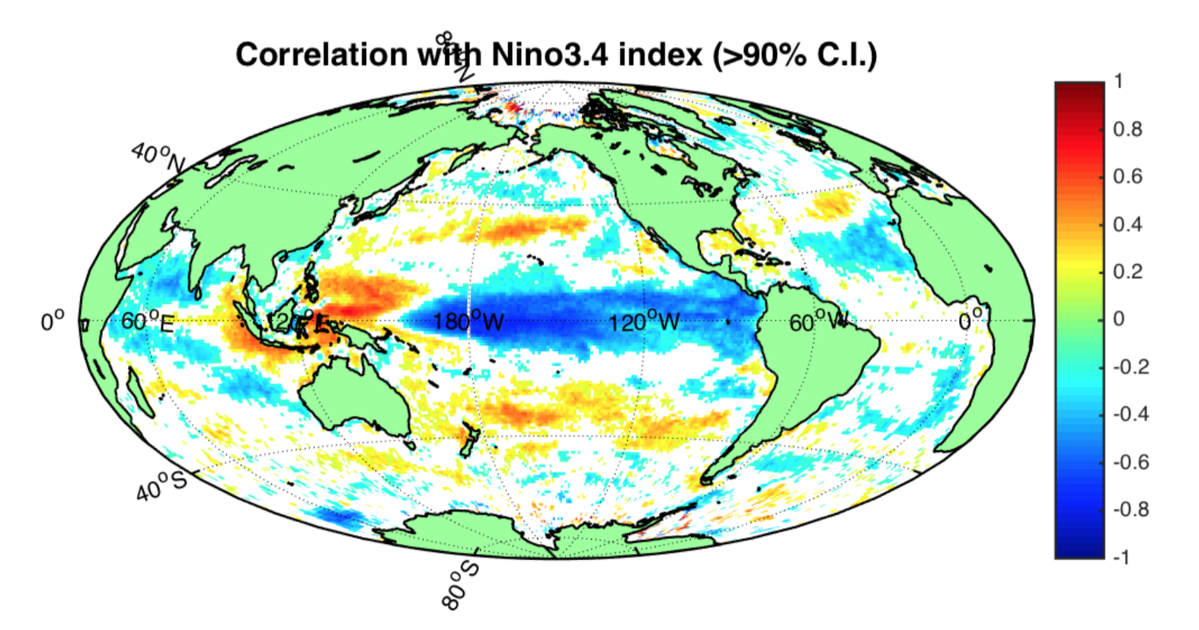
Figure 1. The figure caption should begin with an overall descriptive statement of the figure followed by additional text. They should be immediately after each figure. Figure parts are indicated with lower-case letters (a, b, c…).

3 Descriptive heading for second topic
(Add more sections if neccesary.)

Table 1. Start this caption with a short description of your table. Format tables using the Word Table commands and structures. Additional information on table formatting can be found in our Style Guide, Table Formatting. Do not create tables using spaces or tabs characters. Large tables especially presenting rich data should be presented as separate excel or .cvs files, not as part of the main text.

4 Conclusions
(All figures and tables should be cited in order. Please embed figures, tables, and their captions within the main text near where they are cited.)
References should use a name-date format, not numbers. Enclose citations in parentheses with authors in upright text (non italics) as in: (Smith et al., 2009) or Smith et al. (2009). More information on in-text citations can be found in our Brief Style Guide,“Reference Formatting.”

References
All references must be available to readers at the time of publication; there should be no “unpublished” or “in press” references.
An example of a reference:
Deng, A., & Stauffer, D. R. (2006), On improving 4-km mesoscale model simulations. Journal of Applied Meteorology and Climatology, 45(3), 361–381. doi:10.1175/JAM2341.1
More information on reference formatting with examples can be found in our Brief Guide to AGU Style.

